**UNIVERSITY OF MUMBAI**

A PROJECT REPORT ON

**“IQ TEST”**

SUBMITTED BY

**Miss. Sanjana Yadav (34)**

**Miss. Pooja Prajapati (25)**

Under the guidance of

**Prof. Pradnya Mhatre.**

**Vishnu Waman Thakur Charitable Trust’s**

**VIVA INSTITUTE OF TECHNOLOGY**

**Shirgaon, Virar (East)**

**2023-24**

**Vishnu Waman Thakur Charitable Trust’s**

**VIVA INSTITUTE OF TECHNOLOGY**

**Shirgaon, Virar (East)**



**CERTIFICATE**

**This is to certify that**

**Miss. Sanjana Yadav**

**Miss. Pooja Prajapati**

**Has satisfactorily completed the project entitled**

**(IQ Test)**

**Towards the partial fulfillment of the MASTER OF COMPUTER APPLICATION (MCA) As laid by University of Mumbai.**

____________

____________________

____________________

**Principal**

**External Examiner**

**Internal Guide**

**DECLARATION**

We hereby declare that the project entitled, "IQ TEST” done at Viva Institution OF Technology has not been in any case duplicated to submit to any other university for the award of any degree. To the best of our knowledge other than we, no one has submitted to any other university.

The project is done in partial fulfillment of the requirements for the award of degree of MASTER OF COMPUTER APPLICATION (MCA) to be submitted as mini project first semester project as part of our curriculum.

**ACKNOWLEDGEMENT**

We would like to express our gratitude and appreciation to all those who gave us the possibility to complete this project. A special thanks to our guide, parents, cousins, friends for providing us with our needs and their forever stimulating support.

We take this opportunity to express our deep sense of gratitude towards our project guide **Prof. Pradnya Mhatre** for her help and letting us work as we wished without putting pressure on us.

We also Thanks **Prof. Chandani Patel** Coordinator of MCA in college for supporting us.

We are very thankful to **Mr. Arun Kumar**, the principal of Viva Institution of technology for his kind co-operation in the completion of our project.

I we thankful to our other staff of our department for facilitating us with the necessary requirements and support and co-operation. Our project experience was satisfying, fulfilling acknowledge filled lastly, We would like to thank our college Viva Institution of technology for providing us with proper ambience and supplying us with the right amenities that has helped us to complete this project on time and satisfyingly.

**Abstract**

The objective of this project is to design Online IQ Test web application with user interface which will enable them to play quiz based on their interest. The motivation of this project comes from our desire to learn the increasingly growing field of web designing and their growing popularity by taking up this Project.

If the site is hard to use and easy to forget, it just doesn't matter what technologies was used to create it. Unfortunately, this truth makes many inexperienced programmers underestimate the importance of the way the invisible part of the site is implemented the code, and so on. The visual part of a site gets visitors interested to begin with, but its functionality makes them come back. A web site can sometimes be implemented very quickly based on certain initial requirements, but if not properly architected, it can become difficult, if not possible, to change.

Media Usage growing Day-by-day rapidly and people are easily accessing the internet for various purposes. Performance is also a major thrust area in the Web application which is one of the main reasons why users get attracted to it. Growing user needs should be taken in to concern with new features to be included.

|  |  |  |  |  |
| --- | --- | --- | --- | --- |
|  |  | **INDEX** |  |  |
|  |  | |  |  |
| **Sr. No.** | **Contents** | | **Page No.** |  |
|  |  | |  |  |
|  | **Introduction** | |  |  |
|  | **1.1** | **Introduction** |  |  |
|  | 1.1.1 Problem definition | | 1-3 |  |
| 1 | 1.1.2 Objectives of Project | |  |  |
| 1.1.3 Scope of Project | |  |  |
|  |  |  |
|  | **1.2** | **Technical Details** |  |  |
|  | 1.2.1Overview of Front End | |  |  |
|  | 1.2.2Overview of Back End | |  |  |
|  | **System Study and Planning** | |  |  |
|  | **2.1** | **System Study** |  |  |
|  | 2.1.1 Existing System | |  |  |
| 2 | 2.1.2 Disadvantages of Existing system | | 3-6 |  |
|  | 2.1.3 Proposed System | |  |  |
|  | **2.2** | **System Planning and Schedule** |  |  |
|  | 2.2.1S/W development Model | |  |  |
|  | **System Design** | |  |  |
|  | **3.1** | **Software Requirement** |  |  |
|  | **Specification (SRS)** | | 6-7 |  |
|  | 3.1.1Introduction of SRS | |  |  |
| 3 | 3.1.2Technology Requirements | | 7-8 |  |
| 3.1.2.1Hardware to be used | |  |  |
|  |  |  |
|  | 3.1.2.2Software/tools to be used | |  |  |
|  | **3.2** | **Detailed life Cycle of the Project** |  |  |
|  | 3.2.1Modules | |  |  |
|  | 3.2.2Object Oriented Analysis & Design | |  |  |

|  |  |  |  |  |
| --- | --- | --- | --- | --- |
|  | Diagrams | |  |  |
|  | 3.2.2.1 Use Case Diagram | |  |  |
|  | 3.2.2.2 | Activity Diagram |  |  |
|  | 3.2.2.3 | Class Diagram |  |  |
|  | 3.2.2.4 Sequence Diagram | | 9-12 |  |
|  | 3.2.2.5 Flowchart/DFD/ER diagram | |  |  |
|  | 3.2.3Database | |  |  |
|  | 3.2.3.1Database Table | |  |  |
|  | 3.2.4 I/O Screen Layout | | 13-25 |  |
|  | **Testing** (Any Model explanation in terms | |  |  |
| 4 | of your project) | |  |  |
| 4.1 Methodologies used for testing | | 25-26 |  |
|  |  |  |
|  | 4.2 Types of Testing (Whichever Used) | |  |  |
| 5 | **Conclusion** | | 26 |  |
|  |  | |  |  |
| 6 | **Limitations** | | 27 |  |
|  |  | |  |  |
| 7 | **Future Enhancements** | | 27 |  |
|  |  | |  |  |
| 8 | **References** | | 27 |  |
|  |  |  |  |  |

**IQ Test**

**Introduction**

* 1. Introduction

Enter the world of IQ tests, where the value lies not in tangible goods but in the intangible realm of intellectual prowess. Much like the success witnessed in various online renting platforms catering to specific niches such as car rentals or property leasing, the IQ test project aims to tap into a market where cognitive abilities are the currency. Business enthusiasts are recognizing the potential to invest in this novel venture, leveraging the inherent value of individuals' intellectual capacities to not only enrich minds but also potentially bolster financial portfolios. As the paradigm shifts from traditional ownership models to the dynamic landscape of intellectual renting, the IQ test project emerges as a promising avenue for both personal development and entrepreneurial success.

* + 1. Problem Definition:

The problem addressed by an IQ Test project is the lack of a convenient and efficient platform for testing your IQ and abilities in the specific field based on your fast and correct response of the quiz. Traditional methods to test ourself involve time-consuming paperwork, limited accessibility, and challenges in finding suitable options. Therefore, the goal of the IQ Test project is to provide a user-friendly online platform that streamlines the test process, enhances accessibility, and overall improves the knowledge.

Key problems addressed by the project:

* Limited Access to Comprehensive IQ Testing: Existing IQ testing methods may not be widely accessible, and individuals may face challenges in obtaining a comprehensive assessment of their intellectual capabilities.
* Monetization of Intellectual Abilities: The project aims to address the lack of platforms that allow individuals to leverage their intellectual strengths for personal and potentially financial gain.
* Technological Integration: There is a need for a technologically advanced platform that can deliver accurate and reliable IQ test results in a user-friendly manner, catering to a diverse audience.
* Innovative Approach to Personal Development: The project seeks to redefine how individuals perceive and engage with their intellectual abilities, encouraging a shift from passive recognition to active development and utilization.
  + 1. Objectives of Project:

The main objectives of our project are:

The main objective of an IQ test project can vary based on the goals and intentions of the project stakeholders. Here are several potential main objectives for an IQ test project:

* **Assessment and Measurement:** The primary objective might be to develop a reliable and valid IQ test that accurately assesses an individual's cognitive abilities, providing a standardized measure of intelligence.
* **Accessibility:** Creating an IQ test that is easily accessible to a broad demographic, ensuring that individuals from diverse backgrounds and abilities can participate in the assessment.
* **Innovation in Testing Methods:** Introducing innovative testing methods or approaches that go beyond traditional IQ assessments, aiming to capture a more comprehensive and nuanced understanding of cognitive abilities.
* **Personal Development:** Focusing on the personal development aspect, the project may aim to not only measure intelligence but also provide insights and resources for individuals to enhance their cognitive skills over time.
* **Education and Research:** Serving as a tool for educational institutions or researchers to study and understand cognitive development and intelligence trends within specific populations.
* **Technological Advancements:** Incorporating cutting-edge technology to deliver the IQ test in an efficient, user-friendly, and secure manner, ensuring the reliability and validity of the results.
* **Global Impact:** Aiming to have a global impact by creating an IQ test that transcends cultural and linguistic barriers, providing a universally applicable assessment tool.

The specific objective will depend on the vision and mission of the project, as well as the needs and goals of those involved, whether they be educators, researchers, entrepreneurs, or individuals seeking to understand and enhance their cognitive abilities.

1.1.3 Scope of the Project:

The scope of the IQ test project involves the development of a robust online platform to administer a comprehensive intelligence assessment. This includes the creation of a culturally fair and linguistically diverse set of questions spanning various cognitive domains. The project aims to ensure accessibility to a broad demographic, emphasizing user-friendly features and multilingual support. Ongoing research collaboration with experts in psychology and cognitive science, adherence to ethical guidelines, and global adaptation of the test contribute to the comprehensive scope of this IQ test initiative.

**1.2 Technical Details**

|  |  |
| --- | --- |
| **Title of the Project** | **IQ TEST** |
| **Software Requirements** | **Operating System:** Windows XP or later  **Platform:** Visual Studio Code Editor |
| **Hardware Requirements** | **Processor:** Intel Pentium or More  **Ram:** 512 MB Ram  **Hard Disk:** PC with 20GB  **Others:** Monitor, Keyboard, CPU, Mouse, Printer, Internet Connectivity |

**System Study and Planning**

2.1 System Study

2.1.1 Existing System:

In the current landscape of IQ testing, accessibility and comprehensive evaluation remain key challenges. Individuals seeking an accurate measure of their cognitive abilities face limitations in finding a single platform that offers a wide-ranging intelligence assessment. Existing IQ testing methods often lack inclusivity, with some assessments being culturally biased or restricted to specific linguistic backgrounds.

Moreover, the communication between users and test administrators is often insufficient, hindering the potential for personalized feedback and guidance. The conventional approach to IQ testing is akin to a single rental showroom, offering a limited selection of products. Our IQ test project aims to address these shortcomings by providing a centralized online platform that offers a diverse and culturally fair intelligence assessment. Much like the convenience of renting products from any city or even before reaching a destination, our web-based IQ test platform seeks to provide a universal and user-friendly solution for individuals seeking a comprehensive evaluation of their intellectual capabilities.

2.1.2 Disadvantage of Existing System:

As humans, it is natural to acknowledge that imperfections may exist in any undertaking. Rather than focusing on highlighting someone's disadvantages, our emphasis is on showcasing the strengths and advantages of our project.

* We have meticulously crafted diverse user interfaces for the questions, ensuring that users remain engaged and motivated during their cognitive testing experience.
* Additionally, we've implemented a dedicated section where users can enlighten themselves about which field aligns with their IQ and interests, guiding them toward suitable career endeavors.
* Our project aims to not only provide an accurate assessment of cognitive abilities but also to empower users with valuable insights for personal and professional growth.

2.1.3 Proposed System:

The proposed system is a web-based system which can be accessed by customer from anywhere around the world.

A user registers into this system using the system user interface without any manual approach

The envisioned IQ Test system is designed to be versatile, accommodating any type of cognitive assessment. Through this system, users can effortlessly access and navigate through the cognitive assessment, gaining essential insights into their intellectual capabilities. The administrative component plays a crucial role, allowing administrators to efficiently manage and communicate reservation information, ensuring a smooth and organized process for users and test administrators alike. The proposed IQ Test system aims to revolutionize the way individuals engage with cognitive assessments, fostering a dynamic and accessible platform for intellectual exploration.

**2.2 System Planning and Schedule**

2.2.1 S/W Development Model:

|  |  |  |  |
| --- | --- | --- | --- |
| Task Name | September | October | November |
| Project Planning | 1 week |  |  |
| Learning &  Improvement | 1 week |  |  |
| Learning  Tools |  | 1 week |  |
| Design |  | 1 week |  |
| Coding |  | 2 week |  |
| Testing |  |  | 1 week |

**2.2.1 S/W development Model**

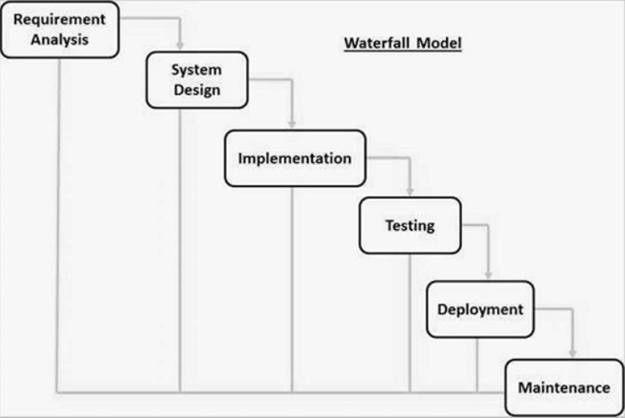

Waterfall approach was first SDLC Model to be used widely in Software Engineering to ensure success of the project. In "The Waterfall" approach, the whole process of software development is divided into separate phases. In this Waterfall model, typically, the outcome of one phase acts as the input for the next phase sequentially.

* **Requirement Gathering and analysis** − All possible requirements of the system to be developed are captured in this phase and documented in a requirement specification document.
* **System Design** − This system design helps in specifying hardware and system requirements and helps in defining the overall system architecture.
* **Implementation** – With inputs from the system design, the system is first developed in small programs called units, which are integrated in the next phase. Each unit is developed and tested for its functionality,
* **Testing** −Post integration the entire system is tested for any faults and failures.
* **Deployment of system** − The product is deployed in the customer environment or released into the market.
* **Maintenance** − There are some issues which come up in the client environment. To fix those issues, patches are released, also to enhance the product some better versions.

**System Design**

* 1. **Software Requirement Specification (SRS)**

**3.1.1 Introduction of SRS**

The production of the requirements stage of the software development process is **Software Requirements Specifications (SRS)** (also called a **requirements document**). This report lays a foundation for software engineering activities and is constructing when entire requirements are elicited and analyzed. **SRS** is a formal report, which acts as a representation of software that enables the customers to review whether it (SRS) is according to their requirements.

**The proposed system has the following requirements:**

* **User Registration and Authentication:**

Users should be able to create accounts securely, and the system must authenticate and authorize access to the IQ test based on user credentials.

* **Intuitive User Interface:**

Design a user-friendly interface that is easy to navigate, ensuring a positive user experience during the cognitive assessment.

* **Adaptive Questionnaire:**

Develop an adaptive questionnaire that tailors the difficulty of questions based on the user's responses, providing a more accurate assessment of their cognitive abilities.

* **Real-time Feedback:**

Provide real-time feedback to users during the assessment, offering insights into their progress and performance.

* **Compatibility and Accessibility:**

Ensure compatibility with various web browsers and devices to make the application accessible to a wide range of users.

* **Scalability:**

Design the application to be scalable, accommodating potential increases in user traffic and incorporating updates or additional features.

**3.1.2.1**

**Hardware to be used**

The recommendation system can work on any internet connected device. These devices should have some limit requirements to make the application run effectively. We expect that the processor speed and internet speed are high.

**Software/tools to be used**

First and foremost, the system is designed to operate seamlessly on any platform, necessitating an internet connection for system access. Additionally, a significant portion of the applications will be coded in Java. Java APIs for database management tools, such as Neoclipse—a standalone workbench application for interacting with Neo4j—will be utilized. Furthermore, query languages like Cypher will be employed in the development process.

**3.2 Detailed Life Cycle of the Project**

**3.2.1 Modules**

1. Registration
2. login
3. Main module
4. Quiz module
5. Database maintenance
6. User result module

**User Registration:**

The User fills the registration form by giving the personal information and successfully registers with the website.

**User Login:**

After successful registration user will do login with the required credentials in the login field

**Main Page:**

After successfully registration the user will navigate on the Main module where he/she can able to view different types of quiz based on different subjects.

**Quiz Module:**

When user will visit to home page there will be different modules like(Science, Computer, History, Math, GK, Grammar), when user will click one of them he/she will navigate on the respected quiz module.

Note: We have meticulously crafted diverse user interfaces for the questions, ensuring that users remain engaged and motivated during their cognitive testing experience.

Additionally, we've implemented a dedicated section where users can enlighten themselves about which field aligns with their IQ and interests, guiding them toward suitable career endeavors.

**Database Maintenance:**

**Firebase:**

Firebase is a NoSQL database service that doesn't use tables in the same way as traditional relational databases like SQL. Instead of tables, Firebase Realtime Database and Firestore use a JSON-like structure to store data.

We exclusively store registered as well as logged in user data using Firebase, a robust app development platform. Firebase is endorsed by Google and widely relied upon by millions of businesses globally. This platform facilitates the creation and expansion of apps and games, making it a trusted choice for managing user information securely.

Firebase Realtime Database stores data as a JSON tree where each node can have many children. It's structured like a JSON tree where each piece of data is referenced by a unique path. Data is organized hierarchically, and changes to any data are immediately synchronized across all clients in real-time.

**3.2.2 Object Oriented Analysis & Design Diagrams**

**3.2.2.3 Use Case Diagram**

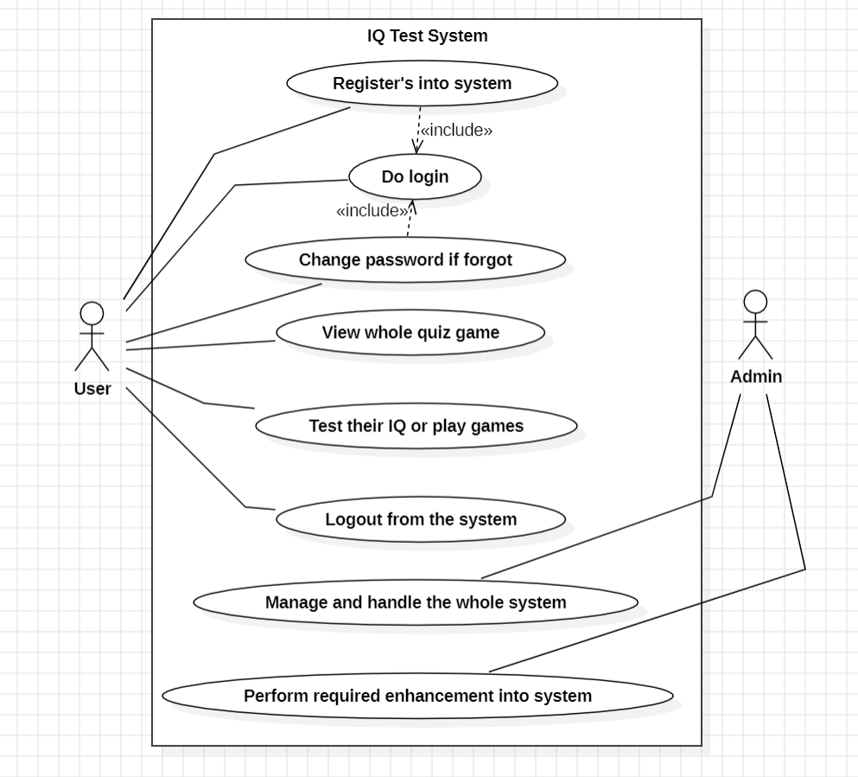

**3.2.2.2 Class Diagram**

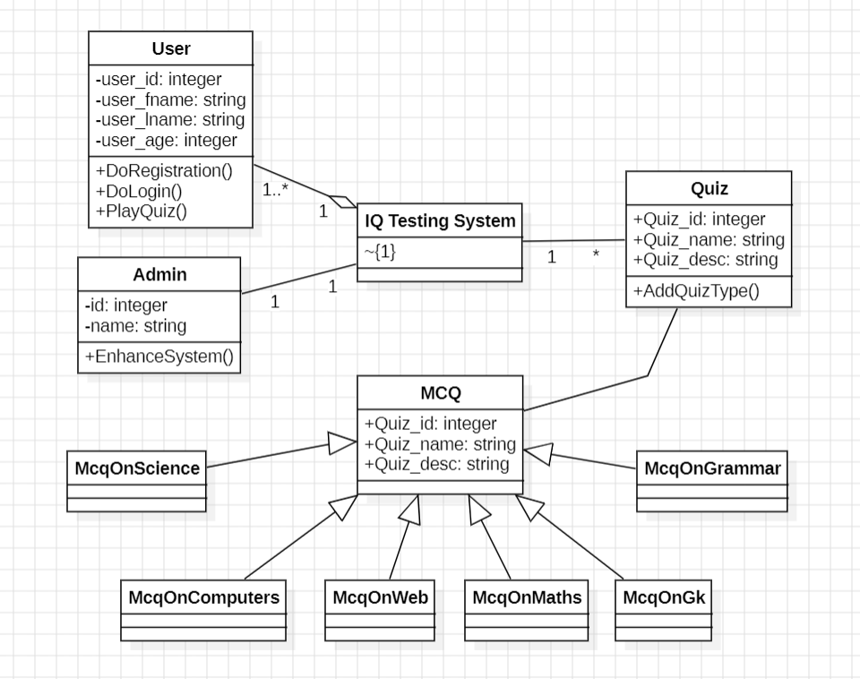

**3.2.2.3 DFD**

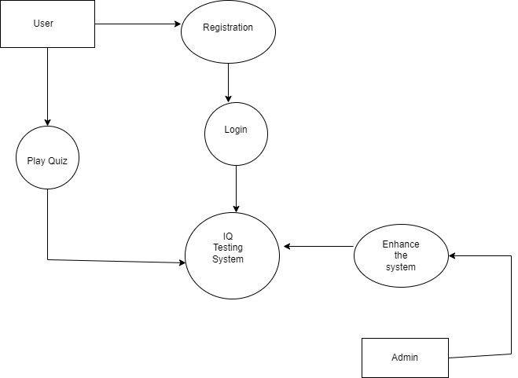

**3.2.2.4 ER-Diagram**

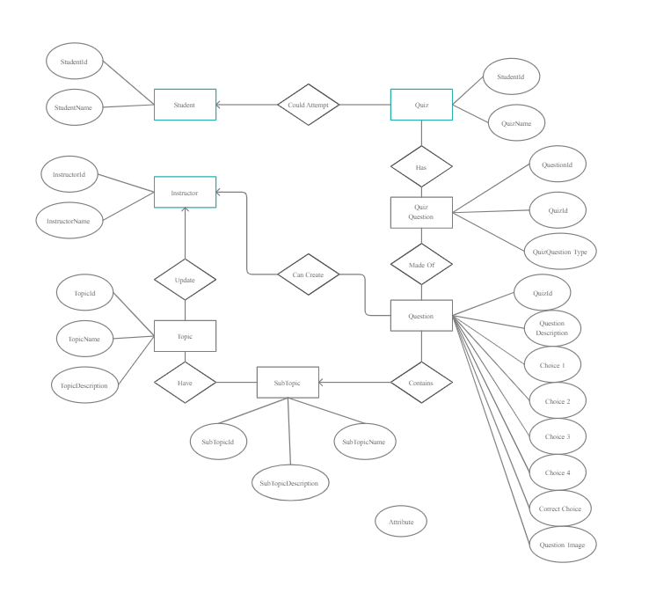

**3.2.2.5 Sequence Diagram**

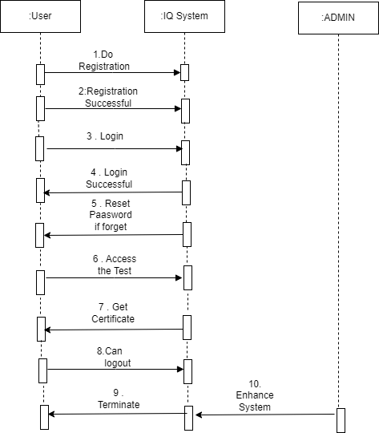

**3.2.2.6 Activity Diagram**

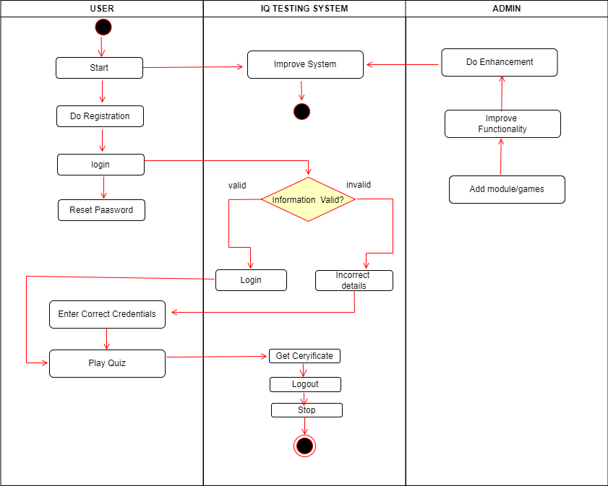

**Screenshots of website**

**Main Module**

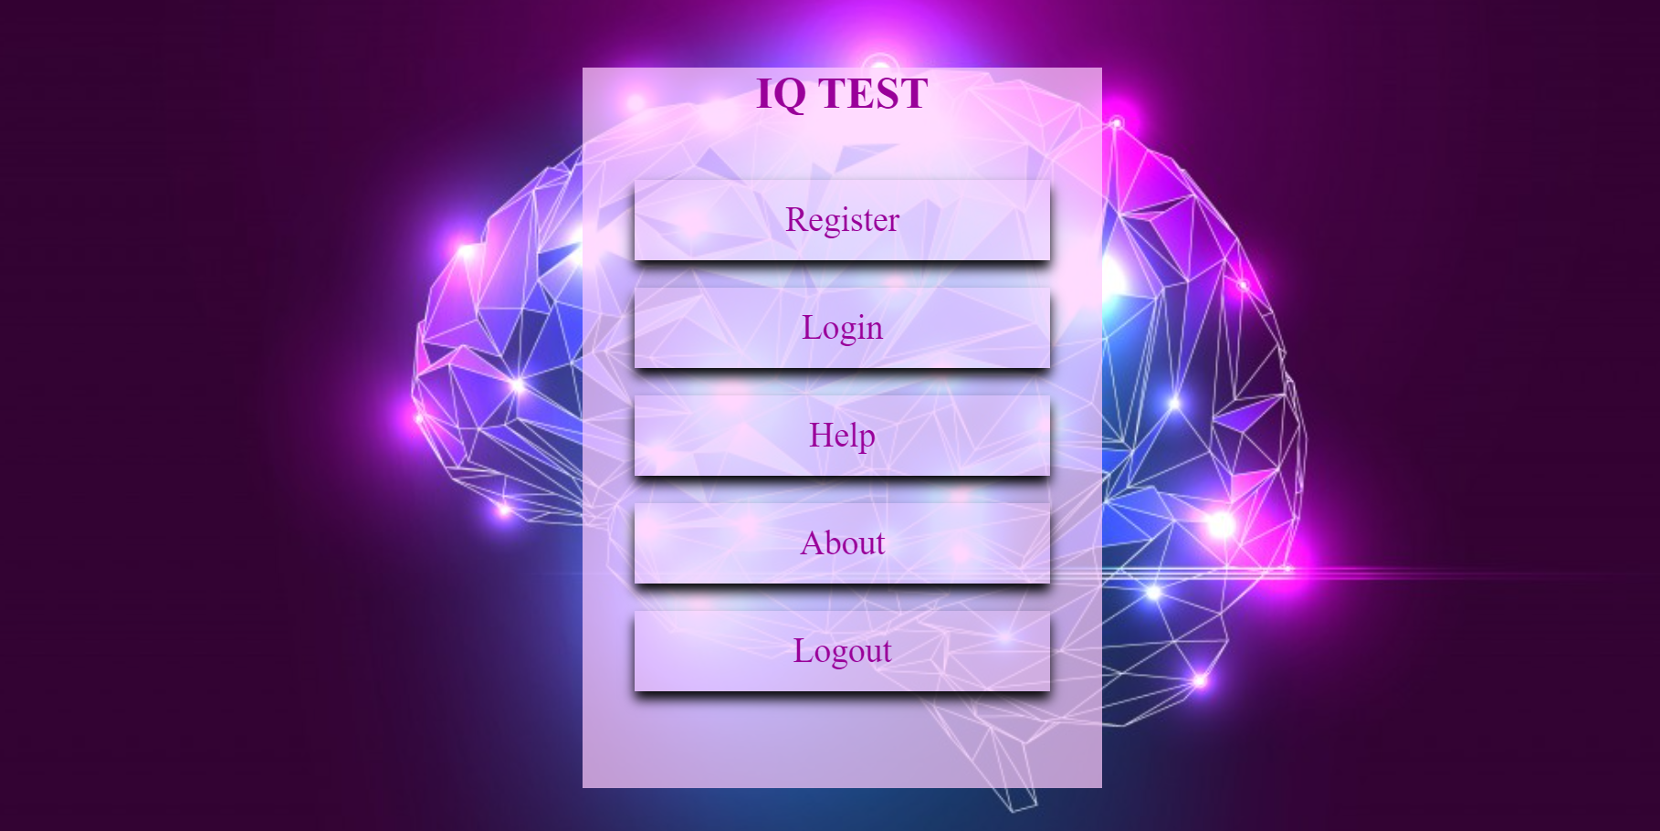

**UserLogin Form**

**User Registration Form**

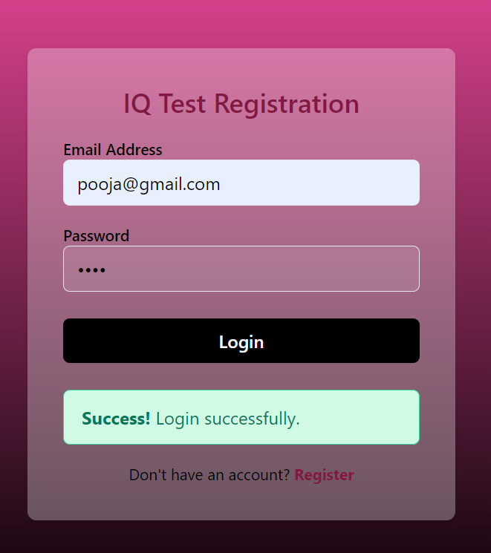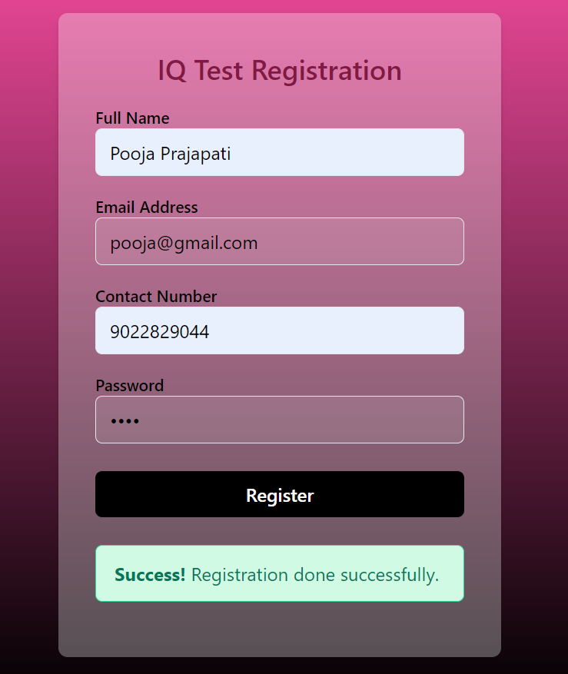

**Help Module**

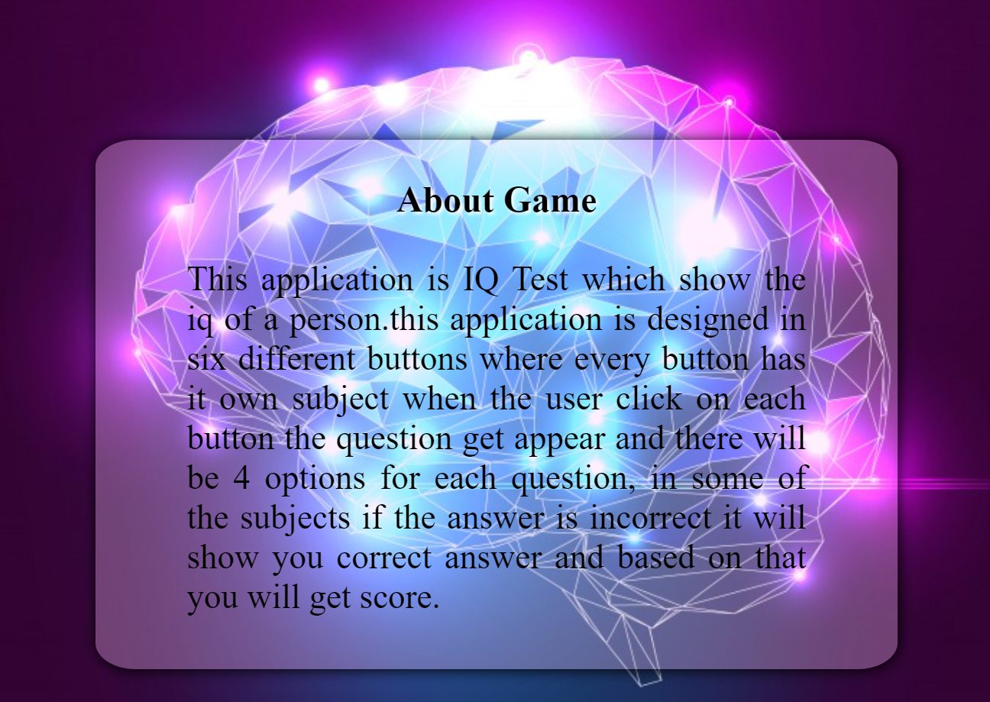

**About Us Module**

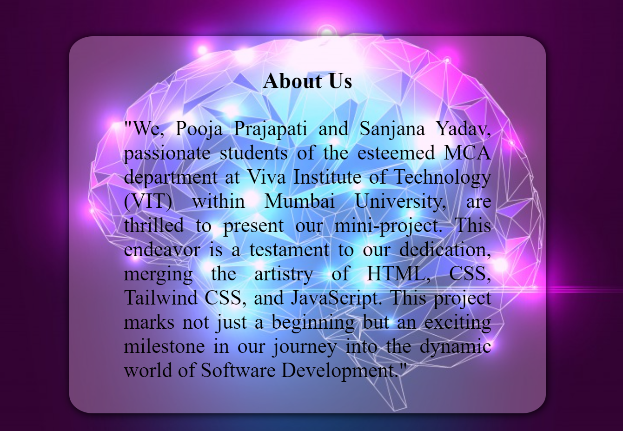

**MCQ Modules**

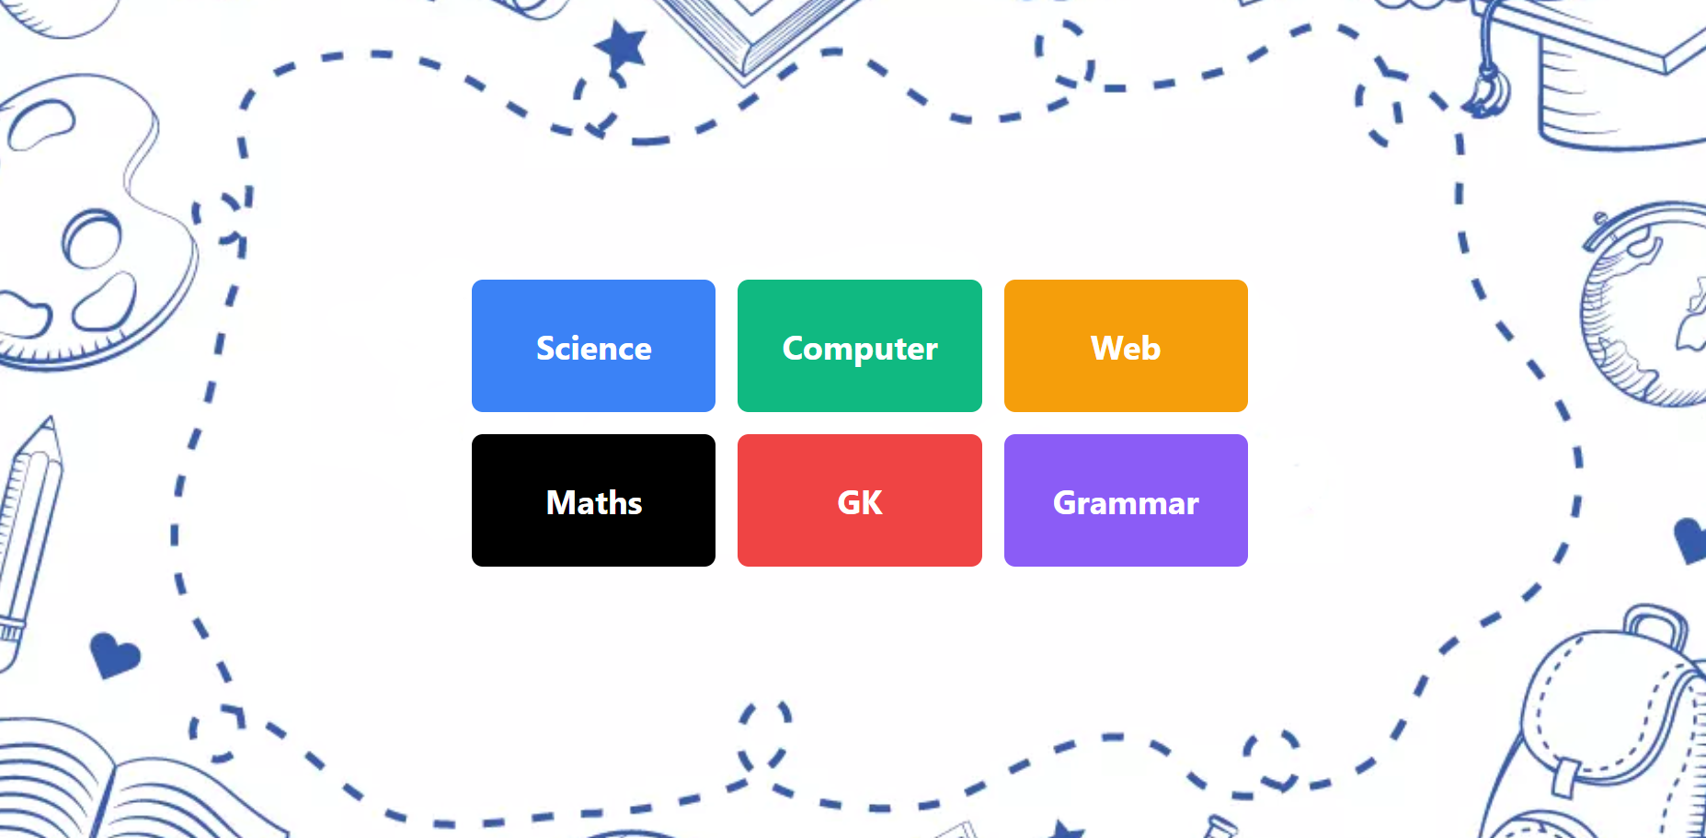

**Quiz Module**

**Science MCQ**

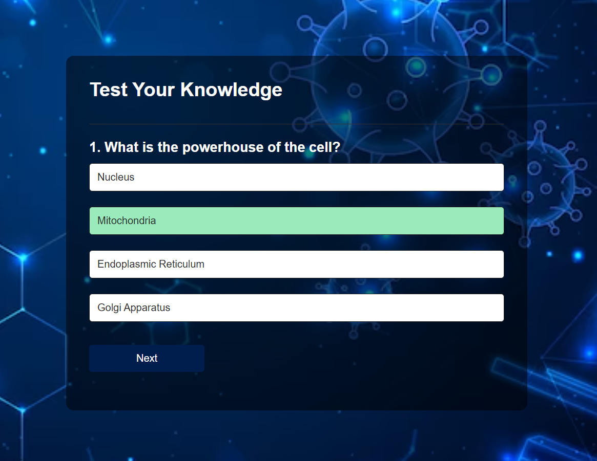

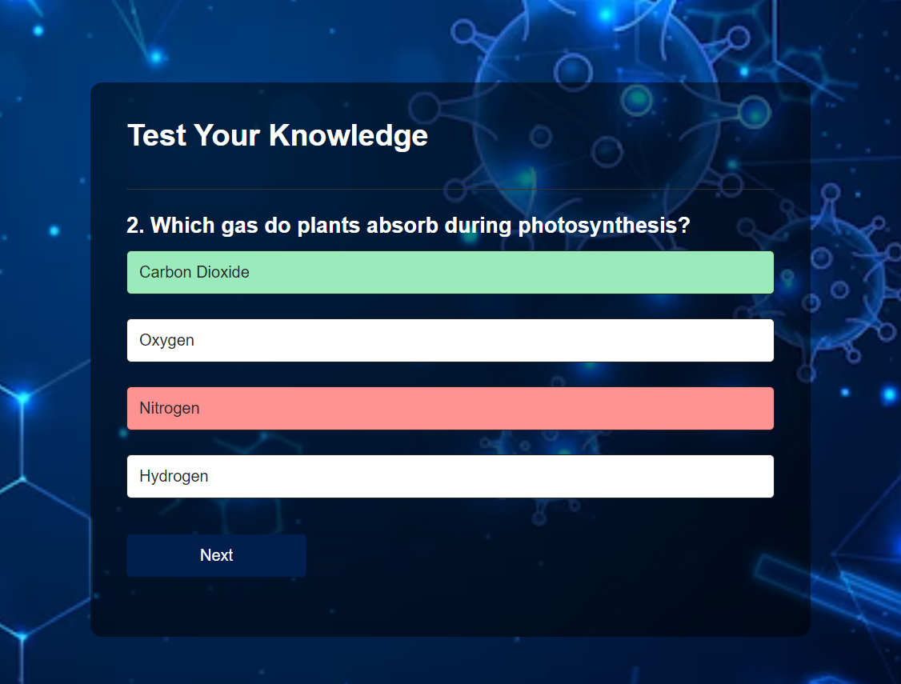

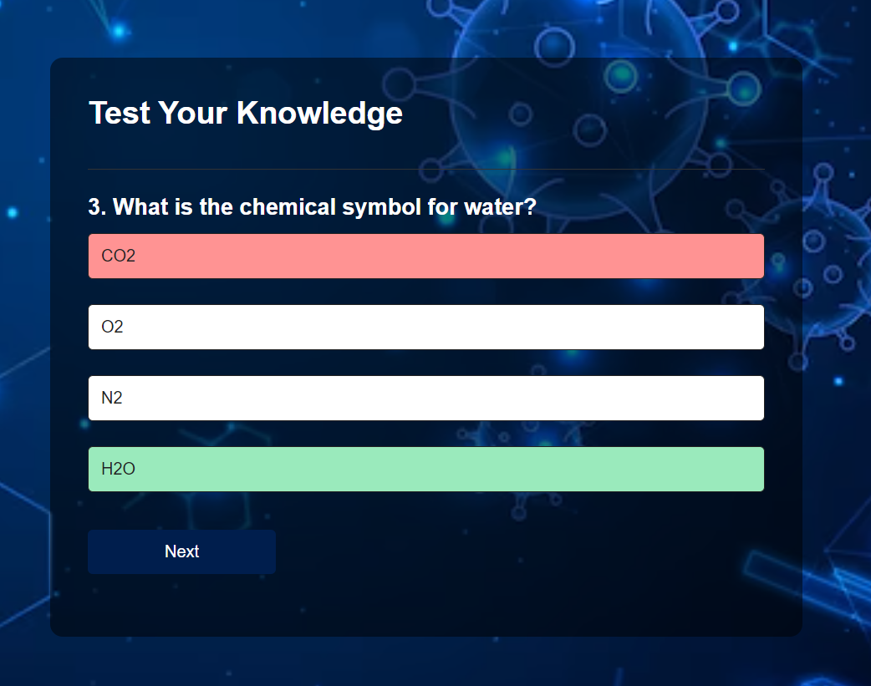

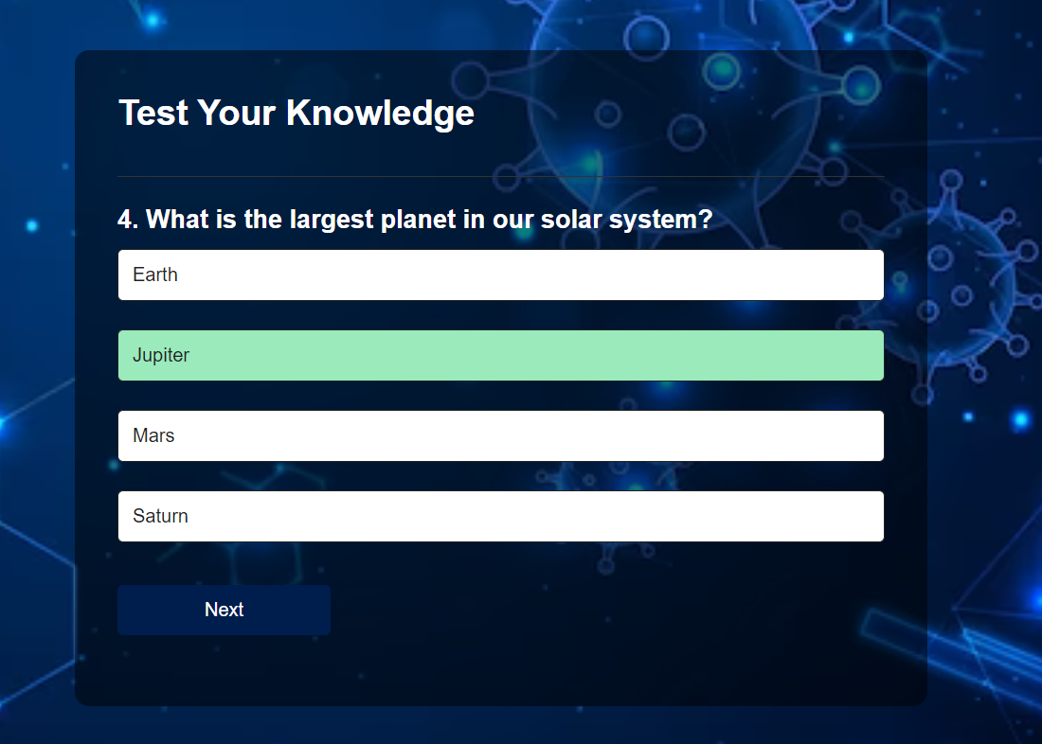

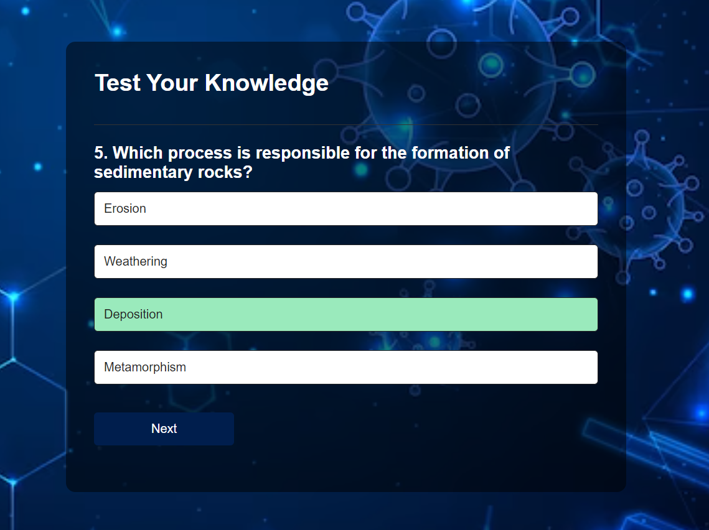

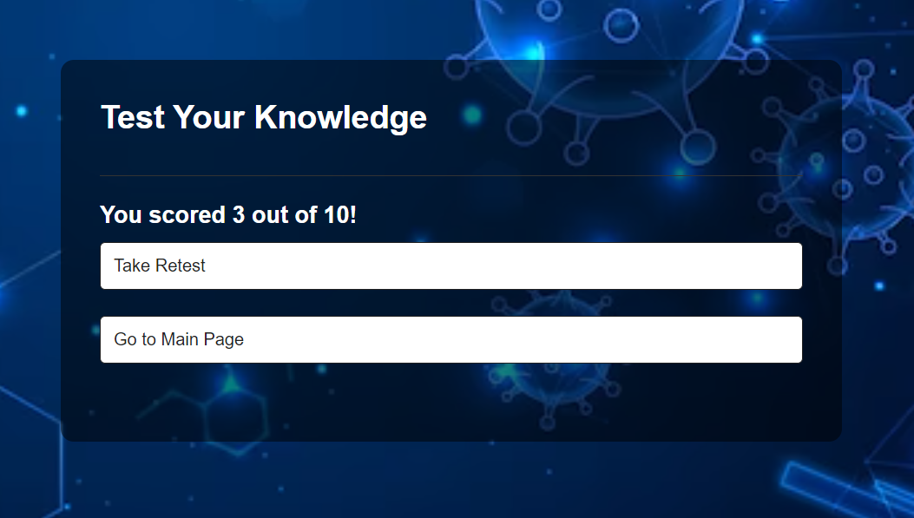

**Computers MCQ**

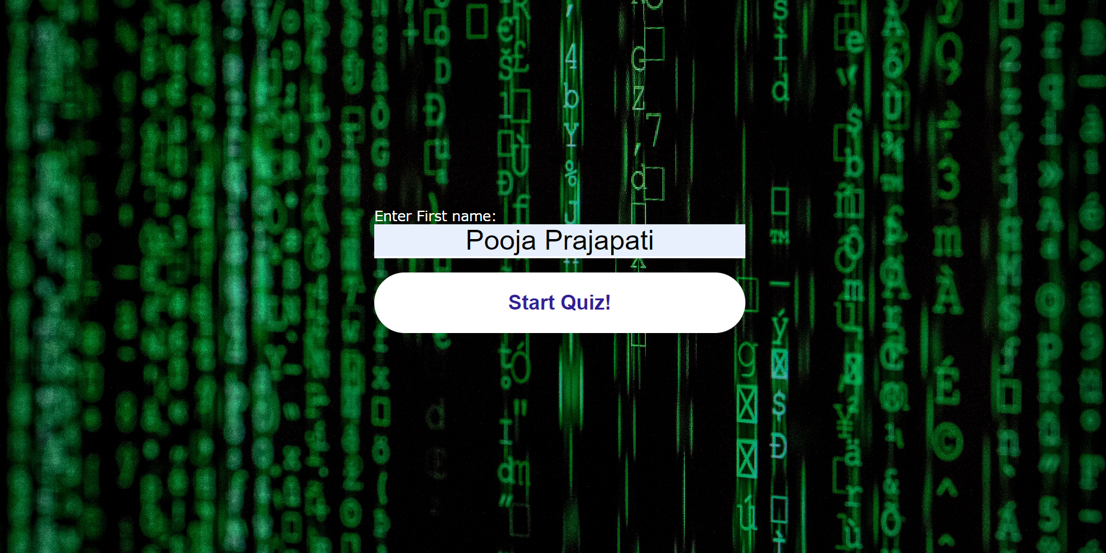

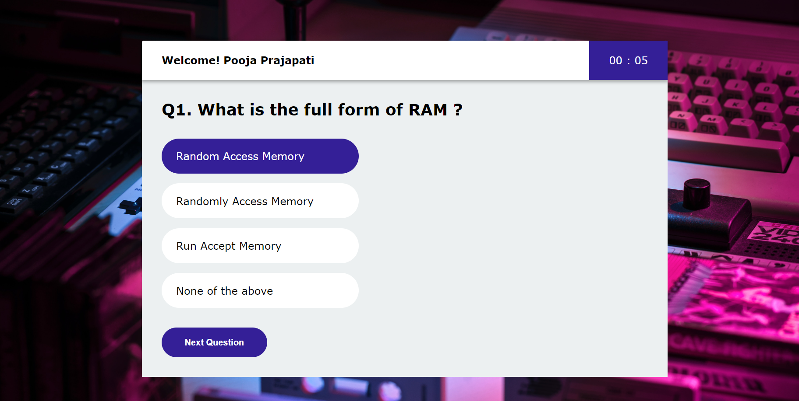

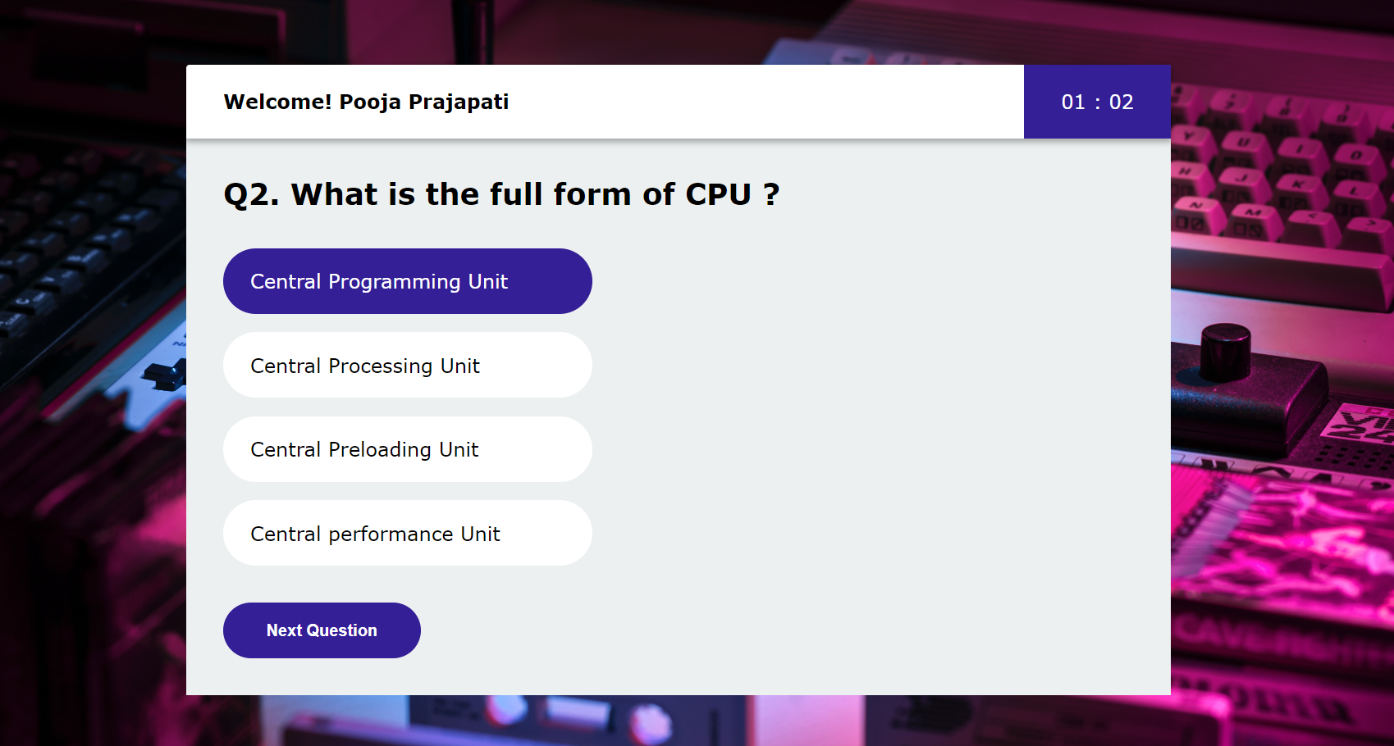

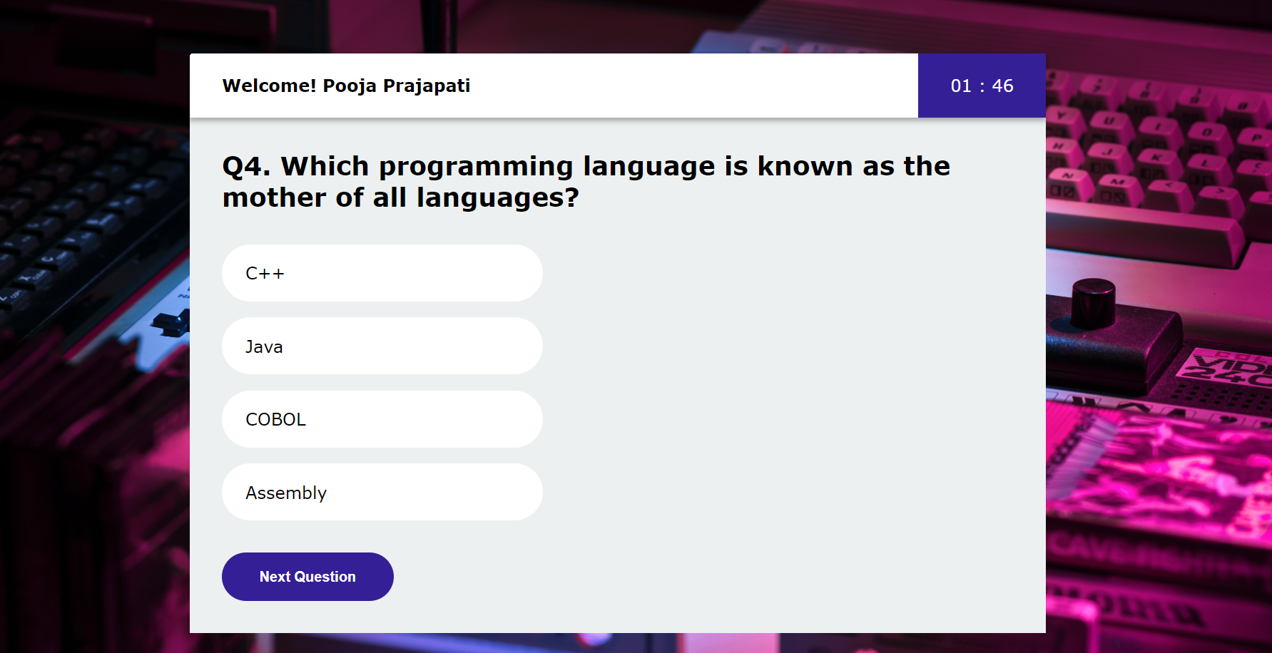

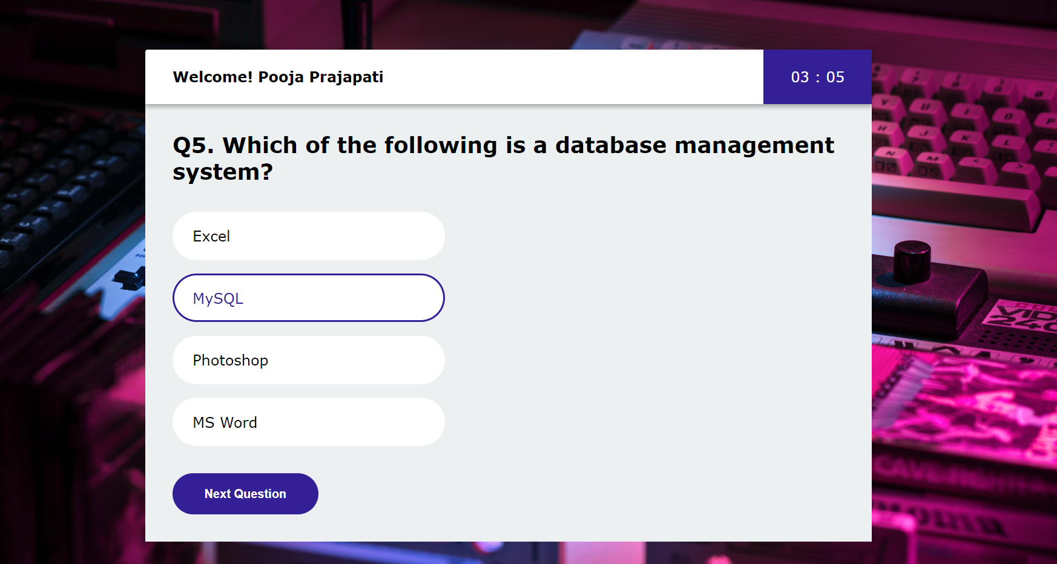



**Maths MCQ**

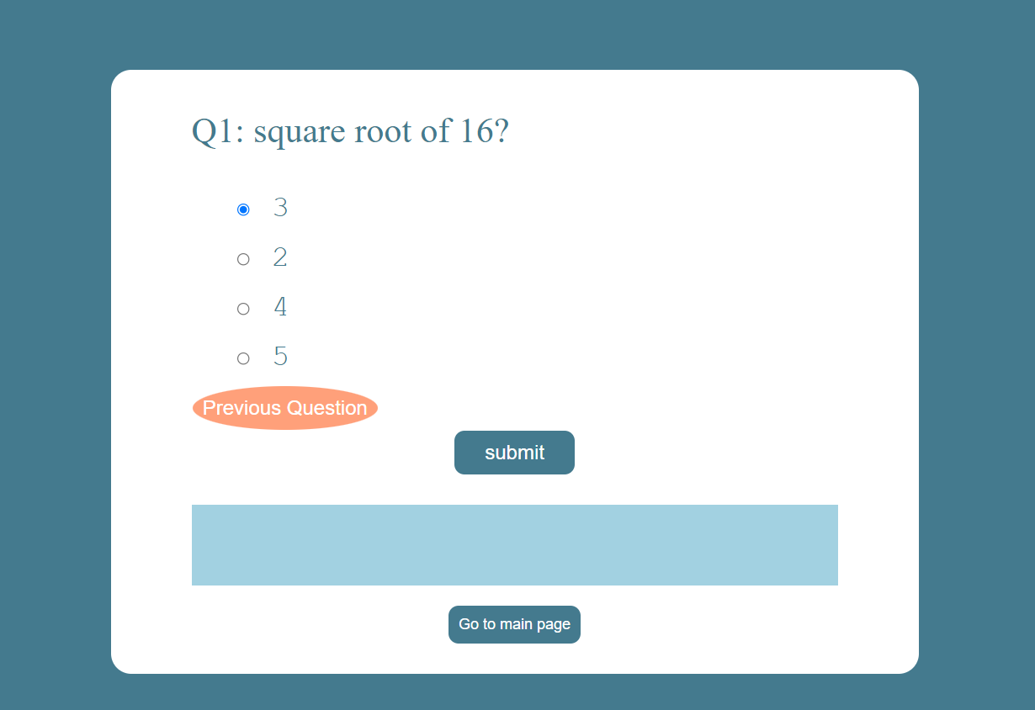

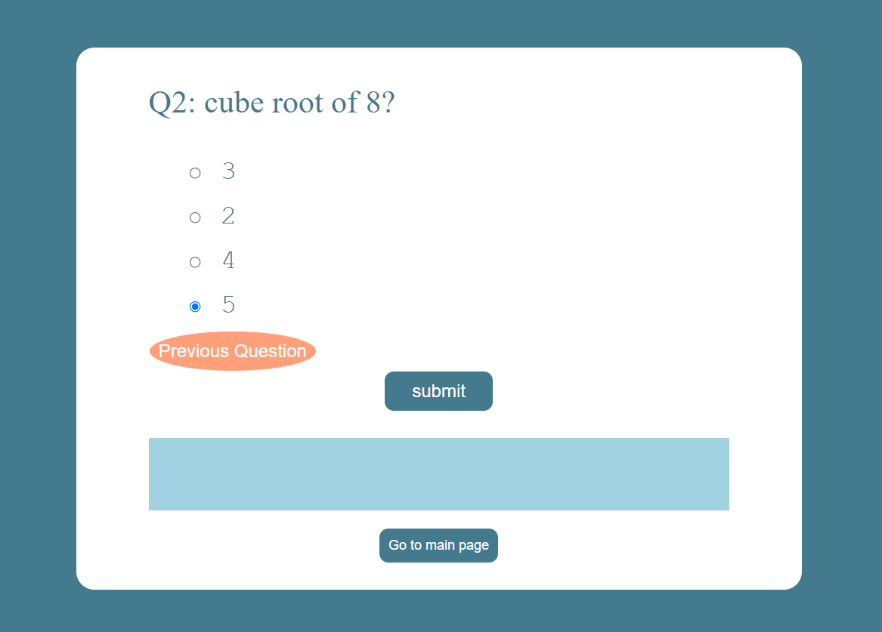

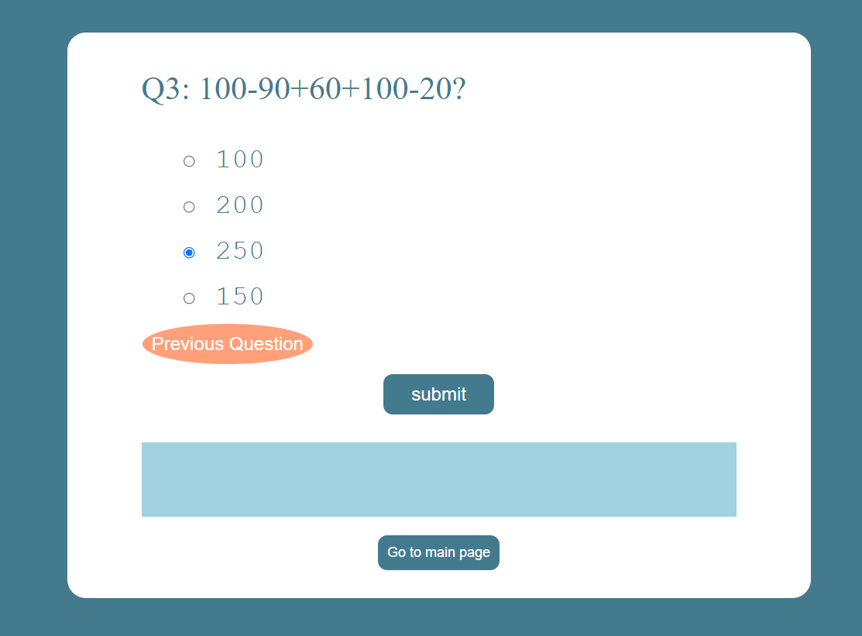

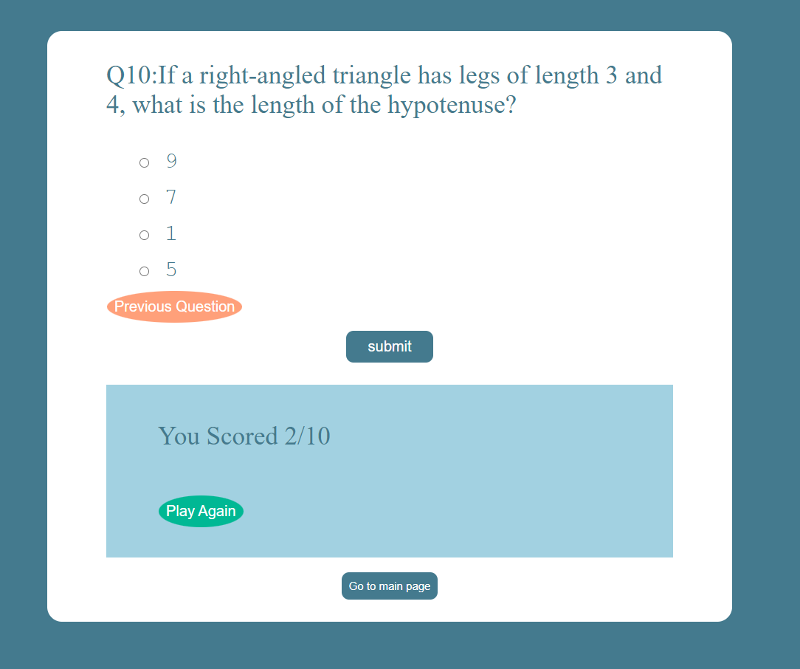

**Database**

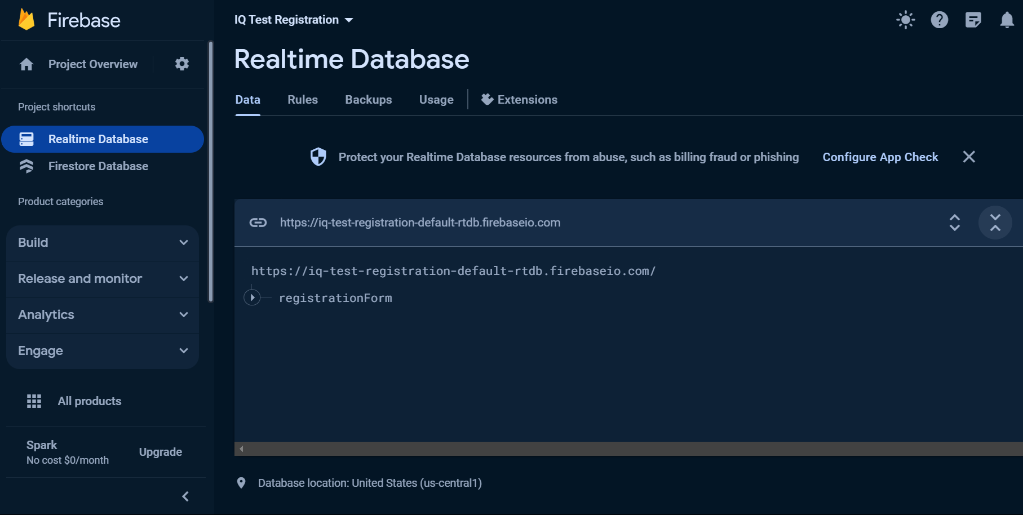

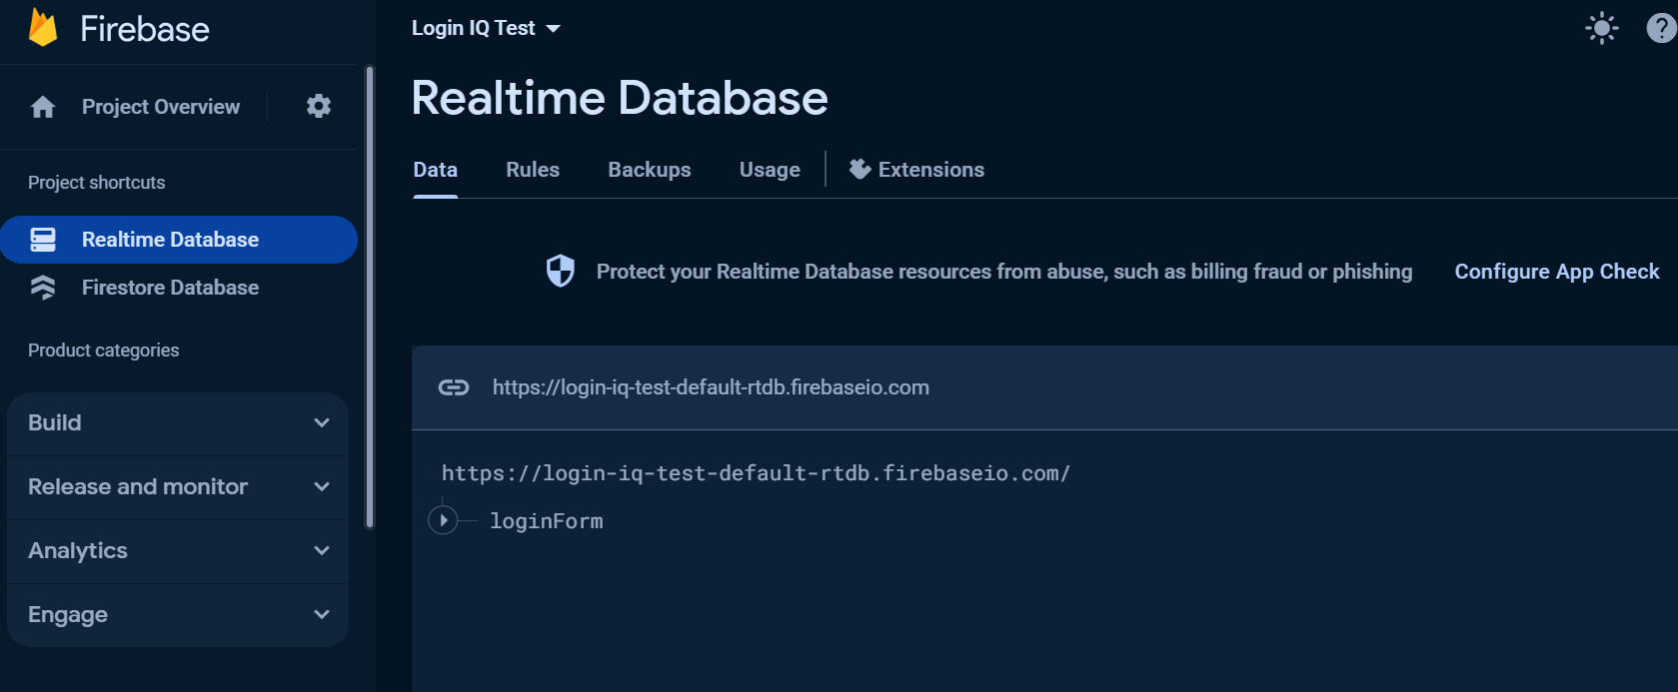

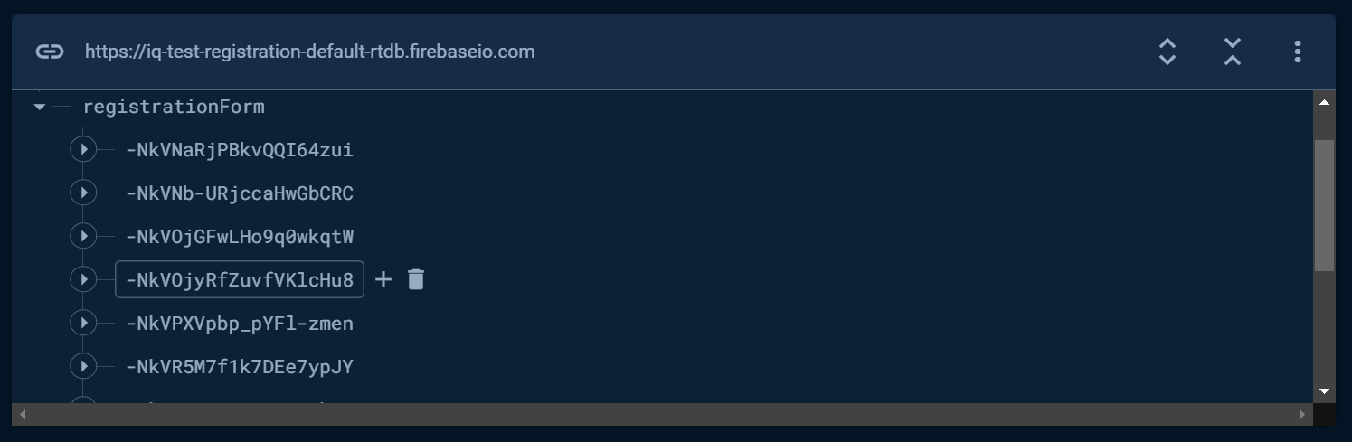

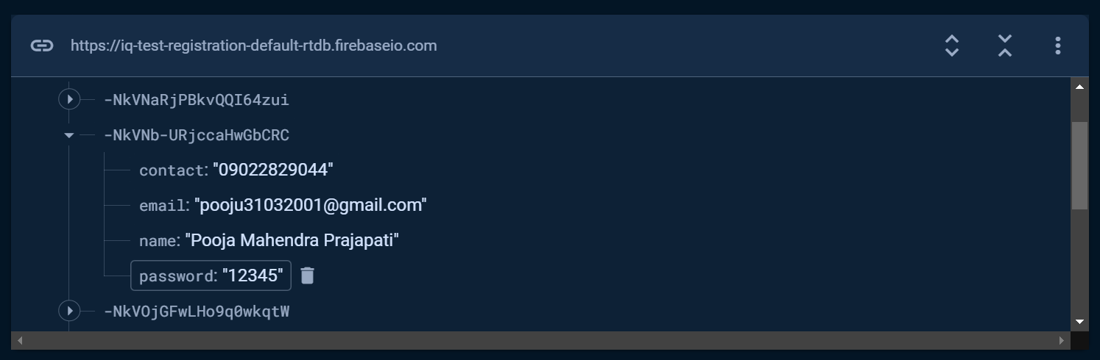

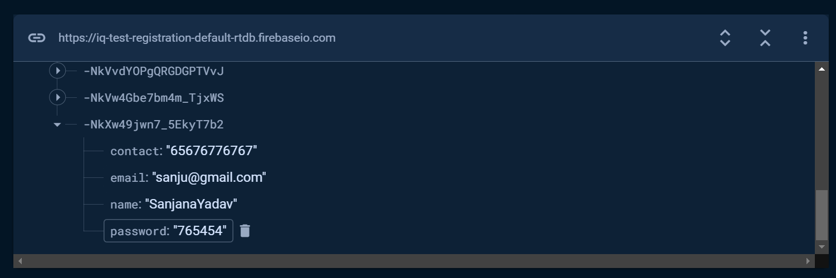

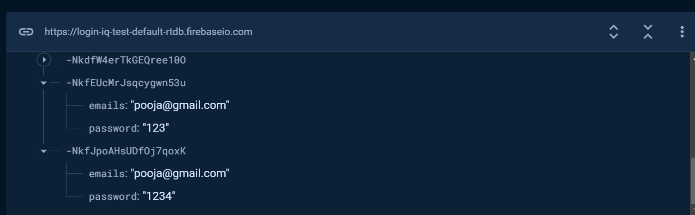

**4.0 Testing**

4.1 **Test case:**

A test case is typically defined as a document that lays out the following:

Test data

* Procedures/inputs
* Scenarios
* Descriptions
* Testing environment
* Expected results
* Actual results

It’s used to for a singular test scenario. As a rule, there are usually both a positive and negative test case for each scenario. The purpose of a test case is two-fold: It’s designed to find any errors or bugs within the software application, and it’s also designed to show how the application should be executed if it performs correctly. It also demonstrates real-world use of the product and whether it fits the customer needs.

**Test plan:**

While a test case is only designed to test a particular scenario, a test plan is a comprehensive document that lays out all major activities associated with a particular testing project. A test plan includes:

Scope of the project

* Objectives
* Target market
* Assumptions
* Testing cycle start/end dates
* Major roles and responsibilities/overall resources
* Testing environment
* Deliverables
* Major risks and how to handle these risks
* Defect reporting and mitigation
* Testing end date

**5.0 Conclusion**

In conclusion, an online rental system project offers several advantages, such as convenience, accessibility, and a wide range of rental options. However, it is important to be aware of the limitations that may arise during its implementation. These limitations include technical issues, internet connectivity challenges, trust and security concerns, limited physical inspection, lack of personalized assistance, geographic restrictions, inventory management challenges, and handling returns and disputes.

Despite these limitations, an online rental system can still be a valuable and profitable venture if the project team addresses these issues effectively. By focusing on enhancing the platform's usability, ensuring robust security measures, providing clear and detailed information about rental items, offering responsive customer support, and implementing efficient inventory management systems, many of the limitations can be minimized or overcome.

Additionally, continuously updating and improving the online rental system based on user feedback and market trends is crucial for its long-term success. By addressing the limitations and consistently refining the platform, an online rental system project can provide users with a seamless and reliable rental experience, ultimately leading to customer satisfaction and business growth.

**6.0 Future Enhancements**

There are some future enhancements of this proposed system.

* **Advanced Question Types:** Integrate a variety of question types beyond multiple-choice, such as interactive puzzles, scenario-based questions, or visual pattern recognition to provide a more comprehensive evaluation of cognitive abilities.
* **Personalized Feedback:** Provide detailed feedback to users, not just on their overall score but also on specific cognitive strengths and areas for improvement, along with recommended resources for further development.
* **Integration with Educational Platforms:** Collaborate with educational platforms to integrate IQ testing as part of a broader educational assessment system, enabling educators and learners to track cognitive development over time.
* **Security Measures:** Implement robust security measures to prevent cheating and ensure the authenticity of test results, especially if the IQ test is used for professional or educational purposes.
* **Technical issues:** IQ Test heavily rely on technology, and technical glitches or failures can disrupt the user experience. This may include website crashes, slow loading times, or errors in processing. These issues can frustrate users and impact the overall usability of the system.
* **Internet connectivity:** IQ Test require a stable internet connection to function properly. In areas with limited or unreliable internet access, users may face difficulties accessing.

And Many more..

**8.0 References**

1. [www.youtube.com](http://www.youtube.com)
2. [www.javatpoint.com](http://www.javatpoint.com)
3. [www.W3school.com](http://www.W3school.com)
4. <https://www.youtube.com/@CodeWithHarry>
5. <https://www.youtube.com/@ApnaCollegeOfficial>

Various other sites.